## 

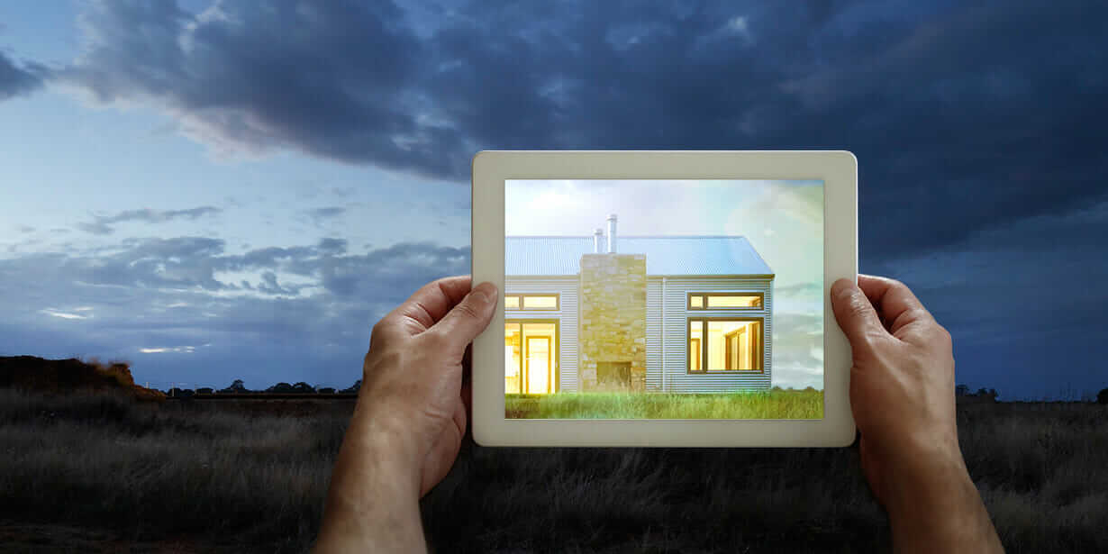

Augmented Reality Construction Application

09.14.2018

**─**

Team Purple:

Michael Cecil

Ocean Lee

Kosha Patel

# Overview:

This project’s overall purpose is to provide an Augmented Reality solution for construction companies to visualize a completed construction project during the course of construction and to provide aid in in the form of tools during various steps of the building process. These tools will be provided via an AR supported device with camera passthrough to view the visualized area of interest. The user will be able to display the completed building, utilize various construction tools during the construction process, and modify the in-progress construction model on any AR supported hardware device. There will be two major layout modes of the application, the viewer and worker mode which will separate the two major use cases of the application for isolating user permissions. We believe that this application will provide a unique value to the construction process and transform the way the construction process is taught and performed.

# Requirements

1. To provide a full 3D to-scale representation of the completed construction project using static reference points.
2. To provide tools for construction workers during the building process to aid in placement and alteration of components.
3. The construction model will be stored on a external server to seamlessly update changes between clients,
4. Must be able to run on both popular mobile platforms: IOS and Android with no major feature loss between operating systems.

# Custom Code/Off-the-Shelf

Considering the visualization tools needed for the application and the cross-platform nature of the product the application will be developed off of the Unity platform. This allows for most of the application to be completely platform independent with the added benefit of being able to support future augmented reality devices such as headsets or google glass-esque hardware. However, all of the development of the features and visualization materials themselves will be developed by us. So the only external products we should be utilizing for the project is a cloud based server host (such as AWS) and Unity as a development platform.

# Cost/Personnel

Software Developers:

* 2 Front-End Devs
* 2 Senior Unity Engineers
* 2 Junior Unity Engineers
* 2 Database/AWS Engineers
* Technical Lead

Resources/Management:

* 1 UI Artist
* Project Manager
* Public Relations/Sales Manager
* Possible Freelance work for additional 3D artwork

Cost:

* Average Software Developer salary - $75,000
* Average Resources - $65,000
* Average Project time - 13 month
* $125 Unity license - 6 Engineers
* Total freelance budget of $40,000
* Total Cost: $983,250

# Justification

This product will provide architects and contractors new ways to design, plan, and share their projects. By using this product, architects will be able to see how their designs will appear in the project site’s environment and make dynamic adjustments. Contractors will be able to plan out the construction far more efficiently by using the app to gauge the spacing and spot any potential risks. Additionally the clients who hired the contractors will be able to get an idea of what the final product will look like, allowing them to better convey their plans.

# Why?

Our organization should pursue this project for the chance to take the lead in, and gain experience in, AR technology. Augmented Reality is a new, growing, field which will offer our company great opportunities in the future. Developing the construction app will give our programmers experience with most aspects of AR development, attract the attention of potential clients in the field, and produce an app which can provide a wide array of services to an already large industry. The coding, experience, and income created from this product will be used to cement our company in the AR industry.